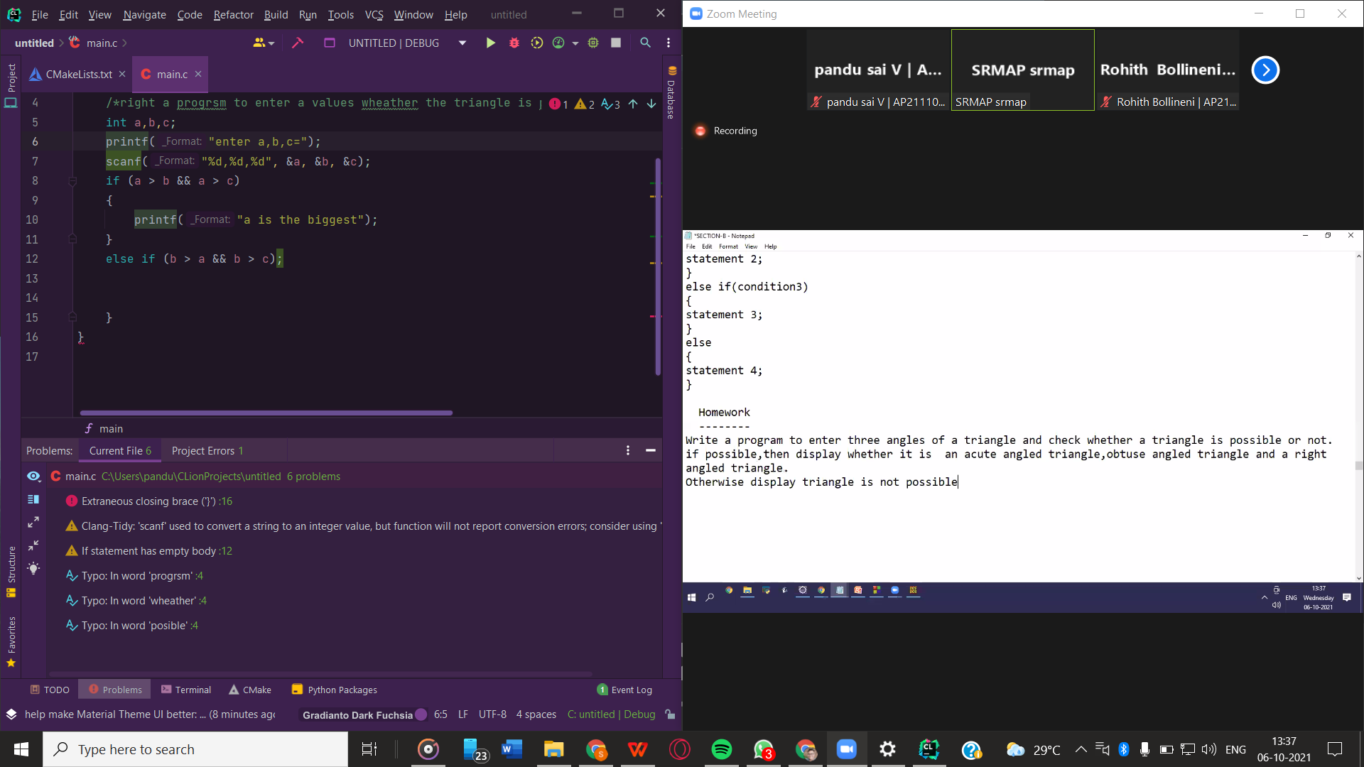

SRM AP

BTECH CSE (CORE)

COURSE NAME: - CSE 105 (INTRODUCTION OF CLANGUAGE)

NAME OF THE STUDENT: -V.D. PANDURANGA SAI GUPTHA

CLASS NOTES

MAIN HEADINGS 16 SIZE

SUB MAIN HEADINGS 14 SIZE

CONTENT 12 SIZE

SUB TO SUB MAIN HEADING 12 RED

**UNIT ONE**

**Introduction of computer**

Computer is a machine which takes raw input (information) and gives the processed output (information).

**Bookish statement :-**

A computer is an electronic device, operating under the control of instructions stored in its own memory that can accept data (input), process the data according to specified rules, produce information (output), and store the information for future use1. Any kind of computers consists of HARDWARE AND SOFTWARE.

**FEAUTURES OF COMPUTER:**

**1.SPEED: -** computer works with a higher speed than humans work it can solves the mathematical equations in micro seconds and nano seconds.

**2.ACCURACY: -** Computer performs 100 % accuracy in mathematical problems if any inaccuracy it made that must made by the user (input information).

**3.DILLEGENCE: -** Computer can perform millions of tasks with accuracy and with the same speed than human beings.

**4.VERSATALITY:** **-** Versatility refers to the capability of a computer to perform different kinds of works with same accuracy and efficiency.

**5.STORAGE CAPACITY: -**storage capacity refers to how much disk space one or more storage devices provides. It measures how much data a computer system may contain. For an example, a computer with a 500GB hard drive has a storage capacity of 500 gigabytes. A network server with four 1TB drives, has a storage capacity of 4 terabytes.

**PERIFERALS OF THE COMPUTER: -**

1. Mouse
2. Keyboard
3. Monitor
4. Tack pad
5. Mouse ball
6. Scanner
7. USB drive
8. Disk drive
9. C.D drive so on…………………….

**TYPES OF COMPUTERS**

1. Micro computer
2. Minicomputer
3. Supercomputer
4. Server computer
5. Laptop
6. Personal computer
7. Workstation computer
8. Main frames

**IMPORTANT COMPUTERS**

**Mainframe Computer: -**It is high capacity and costly computer. It is largely used by big organizations where many people can use it simultaneously.

**Supercomputer: -**This category of computer is the fastest and also very expensive. A typical supercomputer can solve up to ten trillion individual calculations per second.

**DIFFERENCE BETWEEN SUPERCOMPUTER AND MAINFRAME COMPUTER**

Supercomputers are used for large and complex mathematical computations. Mainframes are used as storage for large databases and serve a maximum number of users at a time. Some of the fastest supercomputers operate at hundreds of quadrillions of Floating-point Operations Per Second (FLOPS)

**COMPUTER ARCHITECTURE**

**COMPUTER HARDWARE:** -Computer hardware includes the physical parts of a computer, such as the case, central processing unit (CPU), monitor, mouse, keyboard, computer data storage, graphics card, sound card, speakers and motherboard.

**COMPUTER SOFTWARE:** -Software is the set of instructions that can be stored and run by hardware. Hardware is so termed because it is "hard" or rigid with respect to changes, whereas software is "soft" because it is easy to change.

**TYPES OF SOFTWARE’S**

**APPLICATION SOFTWARE: -**Application software is a software program or group of programs designed for end-users.

**SYSTEM SOFTWARE’S: -**System software provides a platform for other software and includes the programs managing the computer itself, such as the computer’s operating system, file management utilities and disk operating system (or DOS). The system’s files consist of libraries of functions, system services, drivers for printers and other hardware, system preferences and other configuration files. The programs in system software encompass assemblers, compilers, file management tools, system utilities and debuggers.

**OPERATING SYSTEM**

Operating system which manages and maintains the hardware and the software resources the activities and provides common services computer program.

**Examples of operating systems: -** Linux, windows, Mac, mint, kali, ubuntu, oracle Linux, Unix, MS dos.

**OPEN SOURCE**

Open source software (OSS) is software that is distributed with its source code, making it available for use, modification, and distribution with its original rights. ... OSS typically includes a license that allows programmers to modify the software to best fit their needs and control how the software can be distributed.

**Examples for open source software**

1.linux operating system

2.mac operating system

3.compilers so on …………………

**QUESTIONS ASKED**

**MEMORY UNIT: -**Memory unit is a component of a computer system. It is used to store data, instructions and information. It is also known as a main/primary/internal memory.

Data is stored in the form of bytes

1 bytes=8 bits

Bit=0or1

Kilo bytes megabytes

**Memory consists of four types of memory chips RAM, ROM, CMOS and flash.**

**Types of language**

**Low-level or machine level**

**Middle language or assembly language**

**High level**

**INPUT UNIT: -**An input device is something you connect to a computer that sends information into the computer. An output device is something you connect to a computer that has information sent to it.

Functions of operating system

Processor management ;the operating system manages the aloacation of the work

Memory management allocation and deallocation of memory is ensure so that the process doesn’t consume the memory

Divice manage ment: - controls the working of devices like input and out put devices

File management : - keeps the track of creation, deletion and copy and transfer etc…..,directory structure

Security unauthorised access, firewall active, messages regarding the system vulnerabilities

Job scheduling --- in multioperation systems the

Error detection checks the system from external threat by displaying several alerts actions can be taken

Components of os

Shell-----user interactions outer most interaction way to communicate to the system

Kernel----core component of the os ..interface between application and the hardware

Translators

Compilers

Assemblers

Interpreters

System unit

The part of the computer has the primary Units is composed of different unitswhich performs operations and produce results for complex calculations

Which include mother board ,others

Memory unit brlongs this

Primary memory secondary memory

Ram harddisk

And rom

Integer Literals

An integer literal can be a decimal, octal, or hexadecimal constant. A prefix specifies the base or radix: 0x or 0X for hexadecimal, 0 for octal, and nothing for decimal.

An integer literal can also have a suffix that is a combination of U and L, for unsigned and long, respectively. The suffix can be uppercase or lowercase and can be in any order.

Here are some examples of integer literals −

212 /* Legal */

215u /* Legal */

0xFeeL /* Legal */

078 /* Illegal: 8 is not an octal digit */

032UU /* Illegal: cannot repeat a suffix */

Following are other examples of various types of integer literals −

85 /* decimal */

0213 /* octal */

0x4b /* hexadecimal */

30 /* int */

30u /* unsigned int */

30l /* long */

30ul /* unsigned long */

Floating-point Literals

A floating-point literal has an integer part, a decimal point, a fractional part, and an exponent part. You can represent floating point literals either in decimal form or exponential form.

While representing decimal form, you must include the decimal point, the exponent, or both; and while representing exponential form, you must include the integer part, the fractional part, or both. The signed exponent is introduced by e or E.

Here are some examples of floating-point literals −

3.14159 /* Legal */

314159E-5L /* Legal */

510E /* Illegal: incomplete exponent */

210f /* Illegal: no decimal or exponent */

.e55 /* IllegalCharacter Constants

Character literals are enclosed in single quotes, e.g., 'x' can be stored in a simple variable of char type.

A character literal can be a plain character (e.g., 'x'), an escape sequence (e.g., '\t'), or a universal character (e.g., '\u02C0').

**There are certain characters in C that represent special meaning when preceded by a backslash for example, newline (\n) or tab (\t0**

**Operators**

**Arithmetic------+**- %**

**Logical ------$$ll !**

**Relational----<>=**

**Bitwise**

**Shift**

**Unray**

**Increament decrement ----++--**

**Conditional or terenary---??:…if ..else**

**Assignment -----=**

**Comparison …..==**

**Escape sequence character \n\t\v**

**Comments**

**Where improves the the readable part ignore sthe compilers**

**//-- single line comment**

**/*text*/ multi line**

**/**text**

**Sanf(“format specifier”, va**

**Bitwise operators**

**--~&|^**

**A b a&b**

**If the both the aperands are high**

**And bitwise**

**A b a&b**

**0 0 0**

**0 1 0**

**1 0 0**

**1 1 1**

**Bitwise (or)**

**A b a|b**

**0 0 0**

**1 0 1**

**0 1 1**

**1 1 1**

**Bitwise xot**

**This operator results in low in the same value in operands**

**A b a b**

**0 0 0**

**1 0 0**

**0 1 0**

**1 1 1**

**#include <stdio.h>**

**#include <math.h>**

**int main()**

**{**

**/*A is the angle(1) ; B is the angle(2) ; C is the angle(3)*/**

**int A,B,C;**

**printf("\nenter the angle LA=");**

**scanf("%d",&A);**

**printf("\nenter the angle LB=");**

**scanf("%d",&B);**

**printf("\nenter the angle LC=");**

**scanf("%d",&C);**

**if (A+B+C==180)**

**{**

**printf("\ngiven angles form triangle");**

**if (A < 90 && B < 90 && C < 90) {**

**printf("\ngiven triangle is a acute triangle");**

**}**

**if (A > 90 || B > 90 || C > 90) {**

**printf("\ngiven triangle is a obtuse triangle");**

**}**

**if (A == 90 || B == 90 || C == 90) {**

**printf("\ngiven triangle is a right angled triangle");**

**}**

**}**

**else**

**{**

**printf("given values not forms triangle");**

**}**

**return (0);**

**}**